

**A Project**

Report On

**Automation testing using java class on PARABANK website**

**By,**

**SOWMYA SEKAR**

**Batch: SOC(2021-5216)**

**Under the Guidance of,**

**Priyanka Desle**

**(Technical Trainer)**

**EduBridge**

**Introduction:**

This Project aims to do overall testing like functional testing, GUI testing on website to check quality of application. It helps to improve quality of website and saves time for manually doing this testing. In this project our main focus is to check functionalities available on website. Also it includes title check and all links count with their working status.

**Software Requirements:**

Operating System: Window 10

Browser: Latest version of Firefox

IDE: Eclipse IDE

Front-end: Java

**TC01 - Launch the browser and open the Parabank website**

System.*setProperty*("webdriver.gecko.driver", "C:\\Users\\SOWMYA\\Desktop\\jar files\\firefox\\geckodriver.exe");

WebDriver w = **new** FirefoxDriver();

w.get("https://parabank.parasoft.com/parabank/index.htm");

Thread.*sleep*(1000);

**TC02 – To test the functionality of Home button**

w.findElement(By.linkText("home")).click();

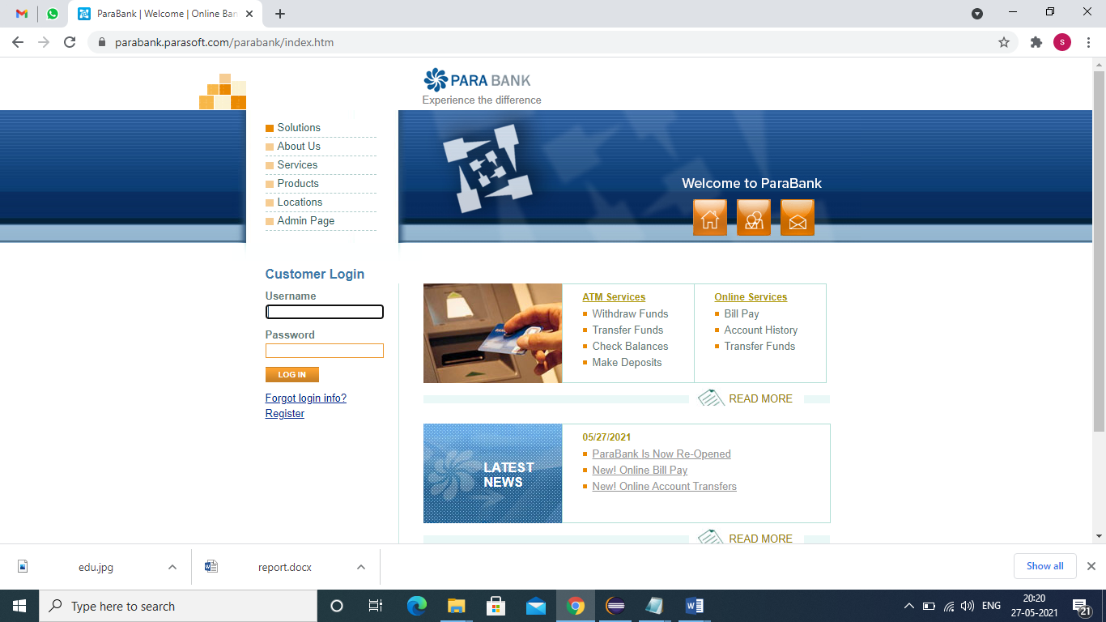

**TC03 – To test the functionality of the Withdraw funds button**

w.findElement(By.linkText("Withdraw Funds")).click();

Thread.sleep(2000);

w.navigate().back();

Thread.sleep(2000);

**TC04 – To test the functionality of Transfer funds button**

w.findElement(By.*linkText*("Transfer Funds")).click();

Thread.*sleep*(2000);

w.navigate().back();

Thread.*sleep*(2000);

**TC05 – To test the functionality of Check balance button**

w.findElement(By.*linkText*("Check Balances")).click();

Thread.*sleep*(2000);

w.navigate().back();

Thread.*sleep*(2000);

**TC06 – To test the functionality of Make deposit button**

w.findElement(By.*linkText*("Make Deposits")).click();

Thread.*sleep*(2000);

w.navigate().back();

Thread.*sleep*(2000);

**TC07 – To test the functionality of Bill pay button**

w.findElement(By.*linkText*("Bill Pay")).click();

Thread.*sleep*(2000);

w.navigate().back();

Thread.*sleep*(2000);

**TC08 – To test the functionality of Account history button**

w.findElement(By.*linkText*("Account History")).click();

Thread.*sleep*(2000);

w.navigate().back();

Thread.*sleep*(2000);

**TC09 – To test the functionality of Transfer funds button**

w.findElement(By.*xpath*("//body/div[@id='mainPanel']/div[@id='bodyPanel']/div[@id='rightPanel']/ul[2]/li[4]/a[1]")).click();

Thread.*sleep*(2000);

w.navigate().back();

Thread.*sleep*(2000);

**TC10 – To test the functionality of Read me button**

w.findElement(By.*xpath*("//body/div[@id='mainPanel']/div[@id='bodyPanel']/div[@id='rightPanel']/p[1]/a[1]")).click();

w.findElement(By.*xpath*("//body[1]/div[1]/div[3]/div[2]/table[1]/tbody[1]/tr[1]/td[2]/a[1]")).click();

Thread.*sleep*(2000);

w.navigate().back();

Thread.*sleep*(2000);

w.navigate().back();

Thread.*sleep*(2000);

**TC11 – To test the functionality of Parabank is now re-opened**

w.findElement(By.*linkText*("ParaBank Is Now Re-Opened")).click();

Thread.*sleep*(2000);

w.navigate().back();

**TC12 – To test the functionality of read me button**

w.findElement(By.*xpath*("//body/div[@id='mainPanel']/div[@id='bodyPanel']/div[@id='rightPanel']/p[2]/a[1]")).click();

Thread.*sleep*(2000);

w.navigate().back();

Thread.*sleep*(2000);

**TC13 – To test the functionality About us button**

w.findElement(By.*linkText*("about")).click();

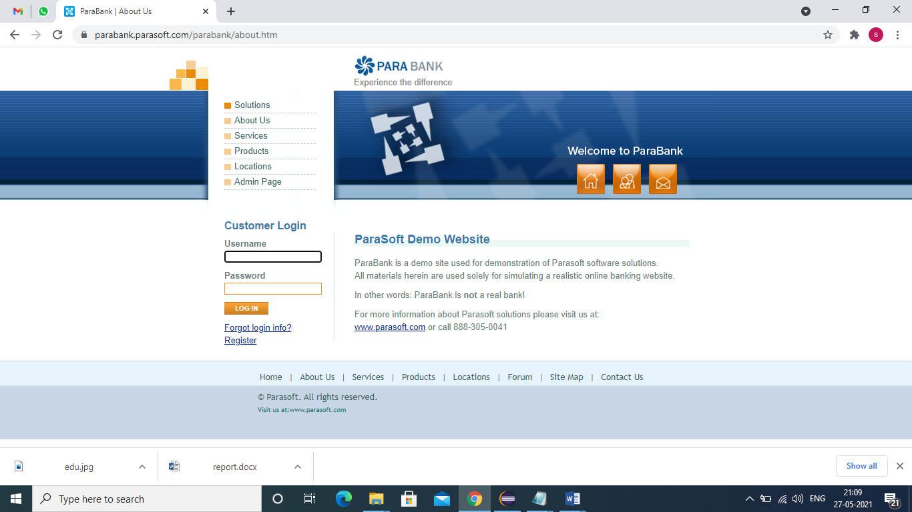

**TC14: To test the functionality of the link test button**

w.findElement(By.*xpath*("//body/div[@id='mainPanel']/div[@id='bodyPanel']/div[@id='rightPanel']/p[3]/a[1]")).click();

Thread.*sleep*(2000);

w.navigate().back();

Thread.*sleep*(2000);

**TC15 : To check the functionality of Customer care button**

w.findElement(By.*linkText*("contact")).click();

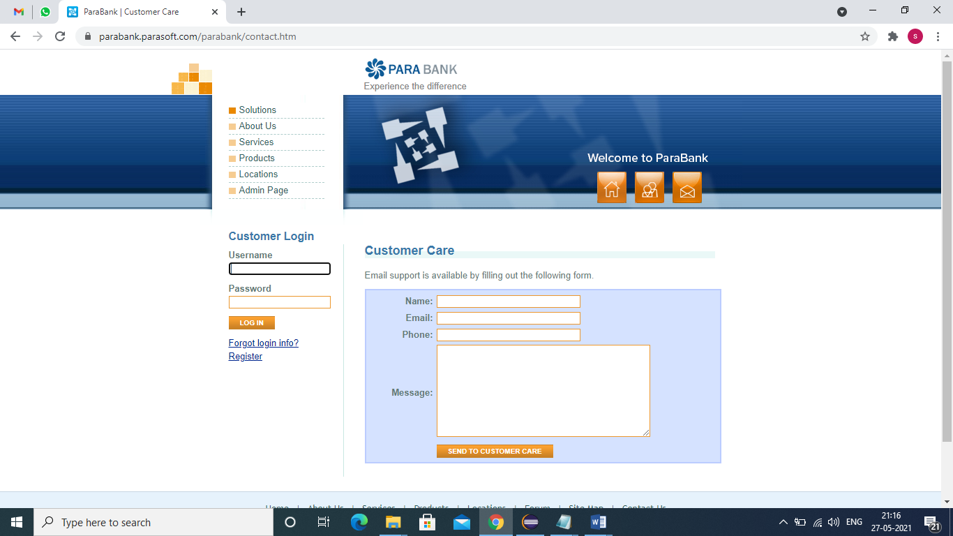

**TC16 – To test the functionality of send to customer care button**

w.findElement(By.*id*("name")).sendKeys("abcd");

w.findElement(By.*id*("email")).sendKeys("abcd@gmail.com"); w.findElement(By.*id*("phone")).sendKeys("1234567890");

w.findElement(By.*id*("message")).sendKeys("good");

w.findElement(By.*xpath*("//tbody/tr[5]/td[2]/input[1]")).click();

Thread.*sleep*(2000);

**TC17 : check the functionality of About Us.**

w.findElement(By.linkText("About Us")).click();

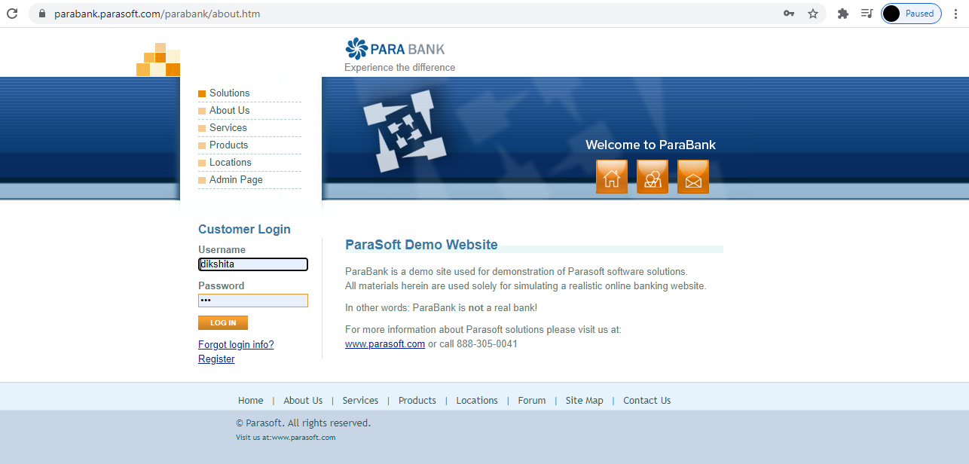

**TC18 : check the functionality of parasoft link**

w.findElement(By.linkText("www.parasoft.com")).click();

JavascriptExecutor hs = ( JavascriptExecutor) w;

hs.executeScript("window.scrollBy(0,1000)","");

Thread.sleep(1000);

w.navigate().back();

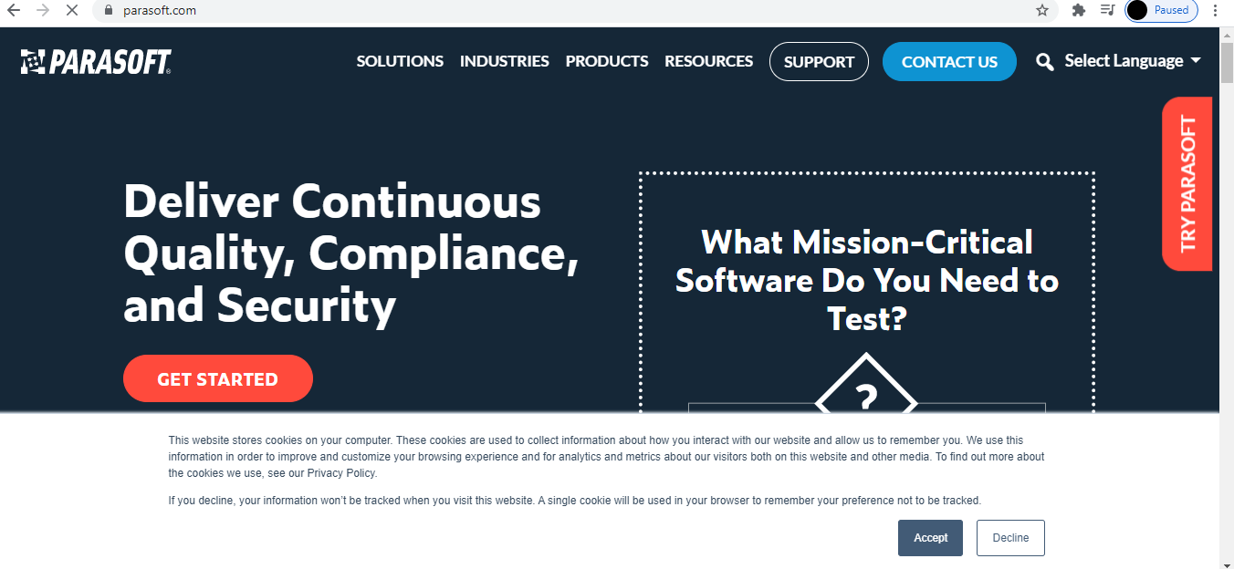

**TC19 : check the functionality of Services**

w.findElement(By.linkText("Services")).click();

JavascriptExecutor ps = ( JavascriptExecutor) w;

ps.executeScript("window.scrollBy(0,1000)","");

Thread.sleep(1000);

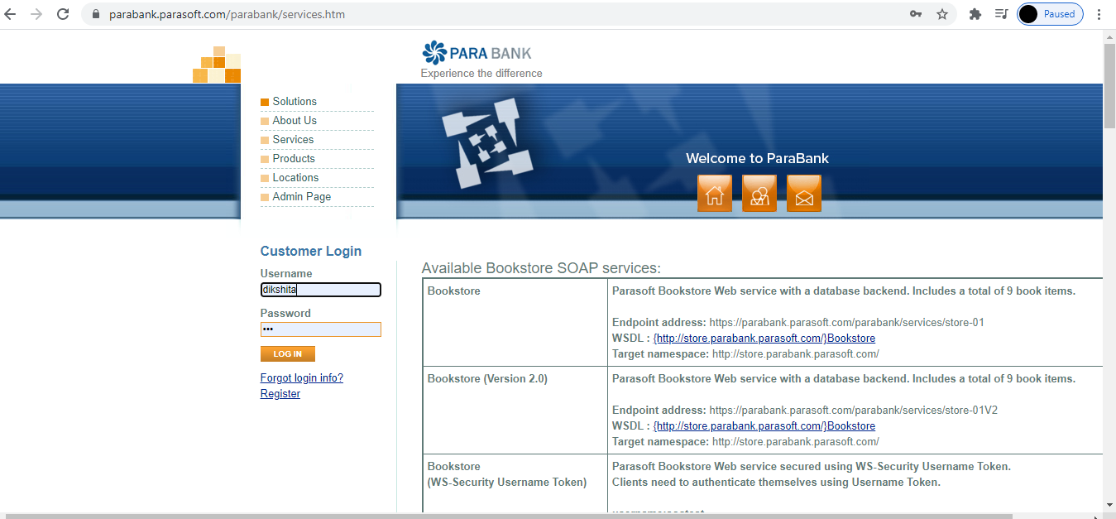

**TC20 : check the functionality of Bookstore link 1**

w.findElement(By.xpath("//*[@id=\"rightPanel\"]/table[1]/tbody/tr[1]/td[2]/a")).click();//Book store services//

JavascriptExecutor js = ( JavascriptExecutor) w;

js.executeScript("window.scrollBy(0,1000)",""); //ScrollDown//

Thread.sleep(1000);

w.navigate().back();

**TC21 : check the functionality of Bookstore link 2**

w.findElement(By.xpath("//*[@id=\"rightPanel\"]/table[1]/tbody/tr[2]/td[2]/a")).click();

JavascriptExecutor j1 = ( JavascriptExecutor) w;

j1.executeScript("window.scrollBy(0,1000)",""); //ScrollDown//

Thread.sleep(1000);

w.navigate().back();

**TC22 : check the functionality of Bookstore link 3**

w.findElement(By.xpath("//*[@id=\"rightPanel\"]/table[1]/tbody/tr[3]/td[2]/a")).click();

JavascriptExecutor j2 = ( JavascriptExecutor) w;

j2.executeScript("window.scrollBy(0,1000)",""); //ScrollDown//

Thread.sleep(1000);

w.navigate().back();

**TC23 : check the functionality of Bookstore link 4.**

w.findElement(By.xpath("//*[@id=\"rightPanel\"]/table[1]/tbody/tr[4]/td[2]/a")).click();

JavascriptExecutor j4 = ( JavascriptExecutor) w;

j4.executeScript("window.scrollBy(0,1000)",""); //ScrollDown//

Thread.sleep(1000);

w.navigate().back();

**TC24 : check the functionality of Bookstore link 5**

w.findElement(By.xpath("//*[@id=\"rightPanel\"]/table[1]/tbody/tr[5]/td[2]/a")).click();

JavascriptExecutor j6 = ( JavascriptExecutor) w;

j6.executeScript("window.scrollBy(0,1000)",""); //ScrollDown//

Thread.sleep(1000);

w.navigate().back();

**TC25 : check the functionality of Bookstore link 6**

w.findElement(By.xpath("//*[@id=\"rightPanel\"]/table[1]/tbody/tr[6]/td[2]/a")).click();

JavascriptExecutor j8 = ( JavascriptExecutor) w;

j8.executeScript("window.scrollBy(0,1000)",""); //ScrollDown//

Thread.sleep(1000);

w.navigate().back();

**TC26 : check the functionality of Bookstore link 7.**

w.findElement(By.xpath("//*[@id=\"rightPanel\"]/table[3]/tbody/tr[1]/td[2]/a")).click();//parabank services/

JavascriptExecutor j9 = ( JavascriptExecutor) w;

j9.executeScript("window.scrollBy(0,1000)",""); //ScrollDown//

Thread.sleep(1000);

w.navigate().back();

**TC27 : check the functionality of Bookstore link 8**

w.findElement(By.xpath("//*[@id=\"rightPanel\"]/table[3]/tbody/tr[2]/td[2]/a")).click();

JavascriptExecutor j10 = ( JavascriptExecutor) w;

j10.executeScript("window.scrollBy(0,1000)",""); //ScrollDown//

Thread.sleep(1000);

w.navigate().back();

**TC28 : check the functionality of Bookstore link 9**

w.findElement(By.xpath("//*[@id=\"rightPanel\"]/table[5]/tbody/tr/td/a[1]")).click();//Available REST ful services//

JavascriptExecutor j11 = ( JavascriptExecutor) w;

j11.executeScript("window.scrollBy(0,1000)",""); //ScrollDown//

Thread.sleep(1000);

w.navigate().back();

**TC29 : check the functionality of Bookstore link 10**

w.findElement(By.xpath("//*[@id=\"rightPanel\"]/table[5]/tbody/tr/td/a[2]")).click();//Available REST ful services//

JavascriptExecutor j12 = ( JavascriptExecutor) w;

j12.executeScript("window.scrollBy(0,1000)",""); //ScrollDown//

Thread.sleep(1000);

w.navigate().back();

Thread.sleep(1000);

w.navigate().back();

System.out.println("These are all services");

**TC30 : check the functionality of Products**

w.findElement(By.xpath("//*[@id=\"headerPanel\"]/ul[1]/li[4]/a")).click();

JavascriptExecutor p=(JavascriptExecutor) w;

p.executeScript("window.scrollBy(0,10000)","");

Thread.sleep(1000);

w.navigate().back();

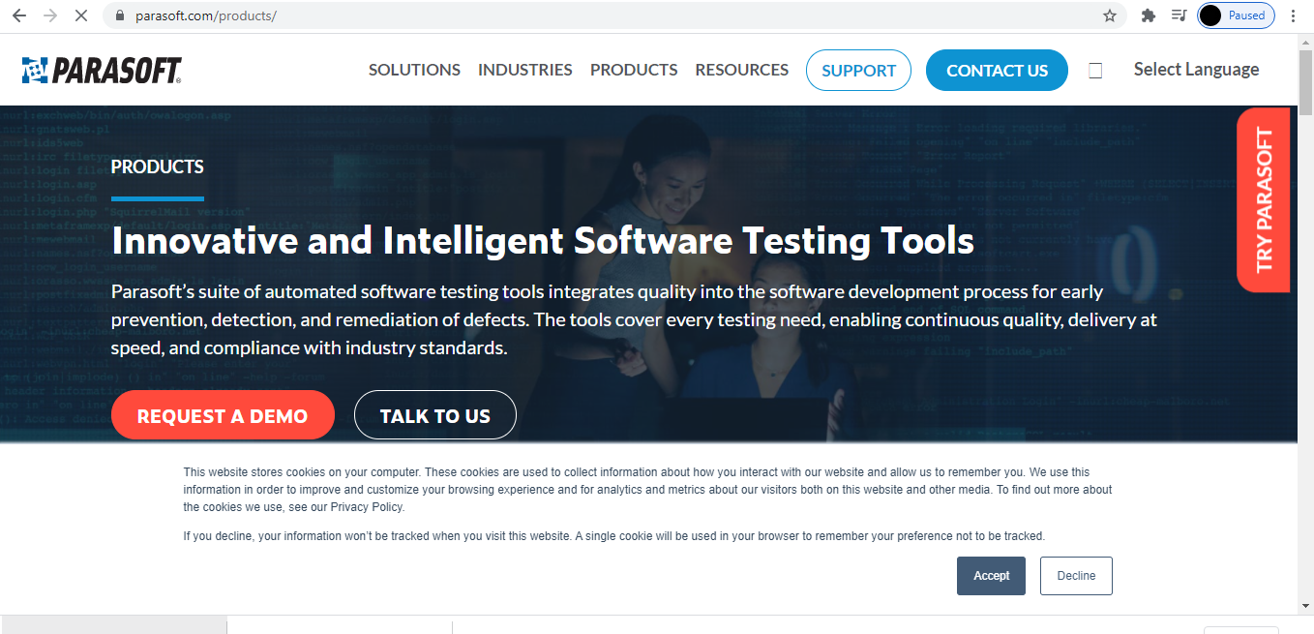

**TC31: check the functionality of Locations Button**

w.findElement(By.xpath("//*[@id=\"headerPanel\"]/ul[1]/li[5]/a")).click();

JavascriptExecutor sj=(JavascriptExecutor) w;

sj.executeScript("window.scrollBy(0,1000)","");

Thread.sleep(3000);

w.navigate().back();

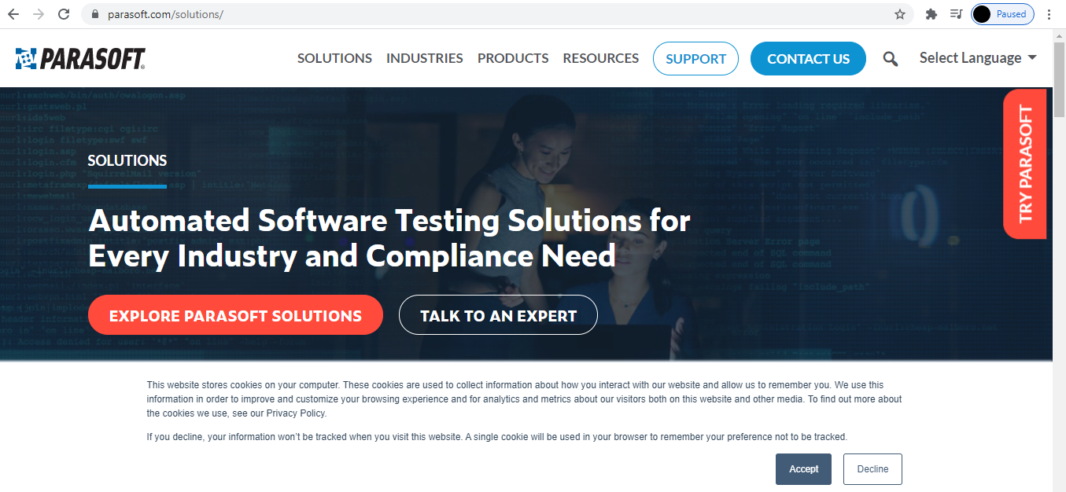

**TC32: check the functionality of Admin Page Button**

w.findElement(By.xpath("//*[@id=\"headerPanel\"]/ul[1]/li[6]/a")).click();

**TC33: To check the functionality of Initialization button** w.findElement(By.xpath("//*[@id=\"rightPanel\"]/table/tbody/tr/td[1]/form/table/tbody/tr/td[1]/button")).click();

System.out.println("Database Initialized");

**TC34 : To check the functionality of clean button**

w.findElement(By.xpath("//*[@id=\"rightPanel\"]/table/tbody/tr/td[1]/form/table/tbody/tr/td[2]/button")).click();

System.out.println("Database Cleaned");

**TC35: To check the functionality of submit button**

w.findElement(By.xpath("//*[@id=\"rightPanel\"]/table/tbody/tr/td[2]/form/table/tbody/tr/td[3]/input")).click();

System.out.println("ShutDown");

WebElement radio1 = w.findElement(By.id("accessMode3"));

radio1.click();

WebElement radio2 = w.findElement(By.id("accessMode1"));

radio2.click();

w.findElement(By.id("soapEndpoint")).sendKeys("abc");

w.findElement(By.id("restEndpoint")).sendKeys("sgdc");

w.findElement(By.id("endpoint")).sendKeys("mmm");

Select m= new Select(w.findElement(By.id("loanProvider")));

m.selectByIndex(0);

Select n= new Select(w.findElement(By.id("loanProcessor")));

n.selectByIndex(0);

w.findElement(By.xpath("//*[@id=\"adminForm\"]/input")).click();

System.out.println("Administration Submitted Successfully");

Thread.sleep(1000);

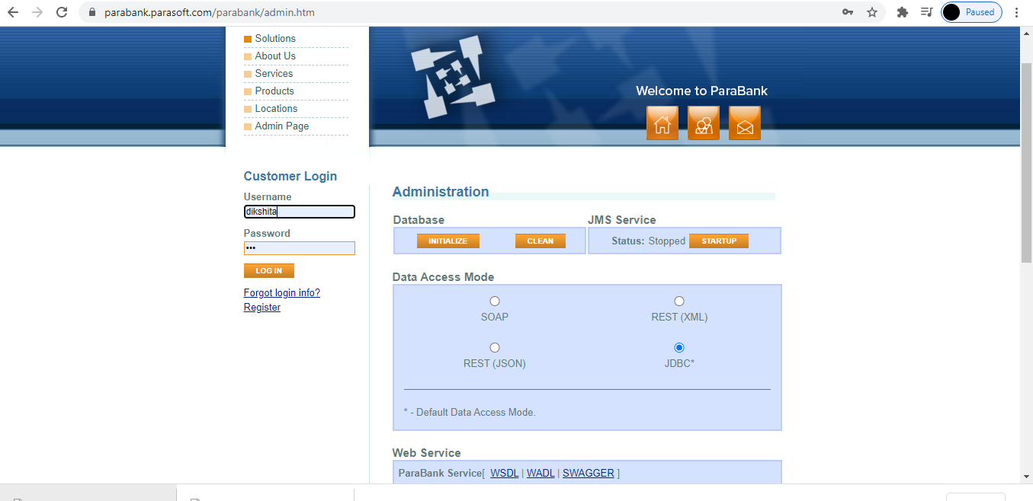

**TC36: check the functionality of Register Button**

w.findElement(By.linkText("Register")).click();

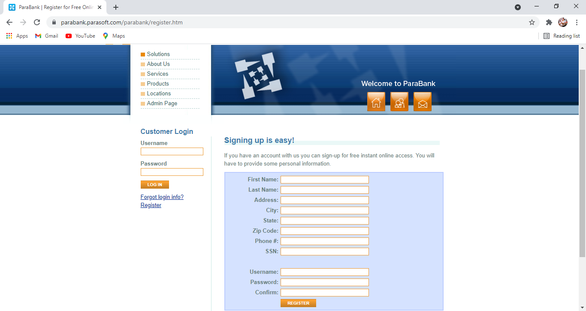

**TC37: To check the functionality of Register button**

w.findElement(By.name("customer.firstName")).sendKeys("Sk"); w.findElement(By.name("customer.lastName")).sendKeys("Appu");

w.findElement(By.name("customer.address.street")).sendKeys("Tenali");

w.findElement(By.name("customer.address.city")).sendKeys("Guntur");

w.findElement(By.name("customer.address.state")).sendKeys("AP");

w.findElement(By.name("customer.address.zipCode")).sendKeys("123456");

w.findElement(By.name("customer.phoneNumber")).sendKeys("6301785201"); w.findElement(By.name("customer.ssn")).sendKeys("803413241567");

w.findElement(By.name("customer.username")).sendKeys("SSAD6");

w.findElement(By.name("customer.password")).sendKeys("Appu@1234");

w.findElement(By.name("repeatedPassword")).sendKeys("Appu@1234");

w.findElement(By.xpath("//tbody/tr[13]/td[2]/input[1]")).click();

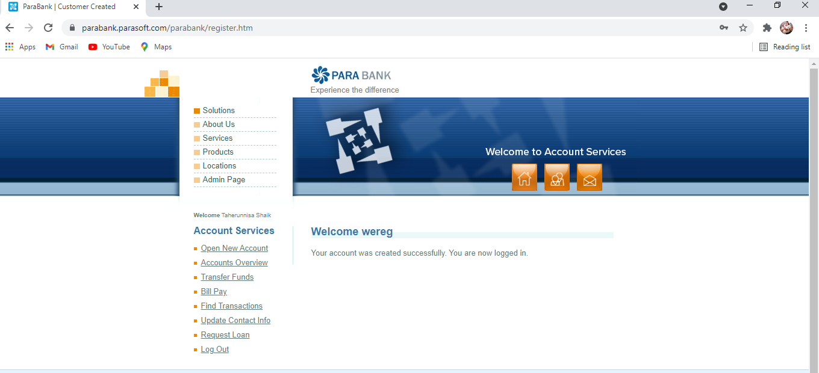

System.out.println("Registration done successfully”);

**TC38: To click on Open New Account**

w.findElement(By.*linkText* ("Open New Account")).click();

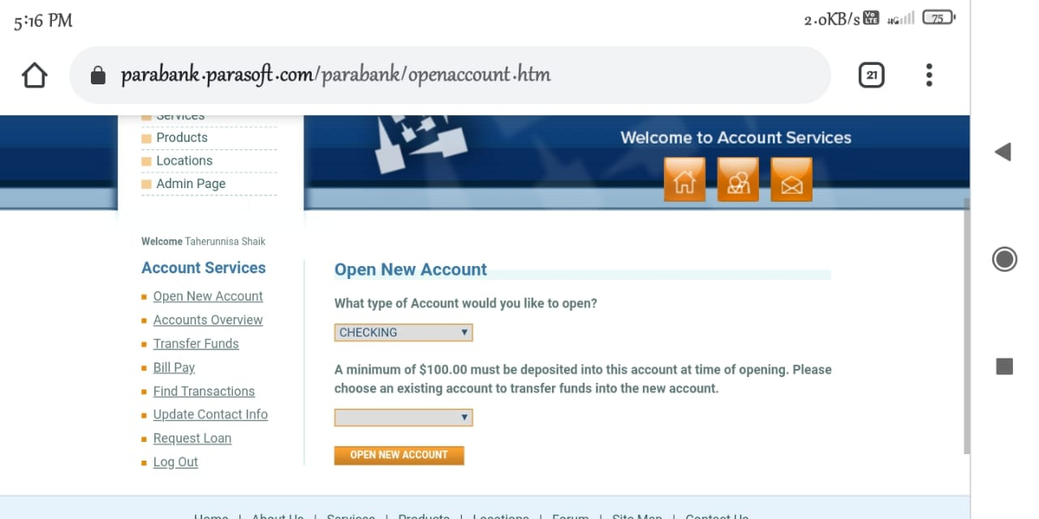

**TC39: To check the functionality of new account**

//for drop down//

Select s=**new** Select(w.findElement(By.*xpath*("//*[@id=\"type\"]")));

s.selectByIndex(0);

Select sa=**new** Select(w.findElement(By.*xpath*("//*[@id=\"fromAccountId\"]")));

sa.selectByIndex(0);

w.findElement(By.*xpath*("//*[@id=\"rightPanel\"]/div/div/form/div/input")).click();

Thread.*sleep*(1000);

**TC40: To click on account overview**

//overview//

w.findElement(By.*linkText*("Accounts Overview")).click(); //account overview

**TC41: To click on Transfer button**

w.findElement(By.*xpath*("//*[@id=\"leftPanel\"]/ul/li[3]/a")).click(); //transfer funds

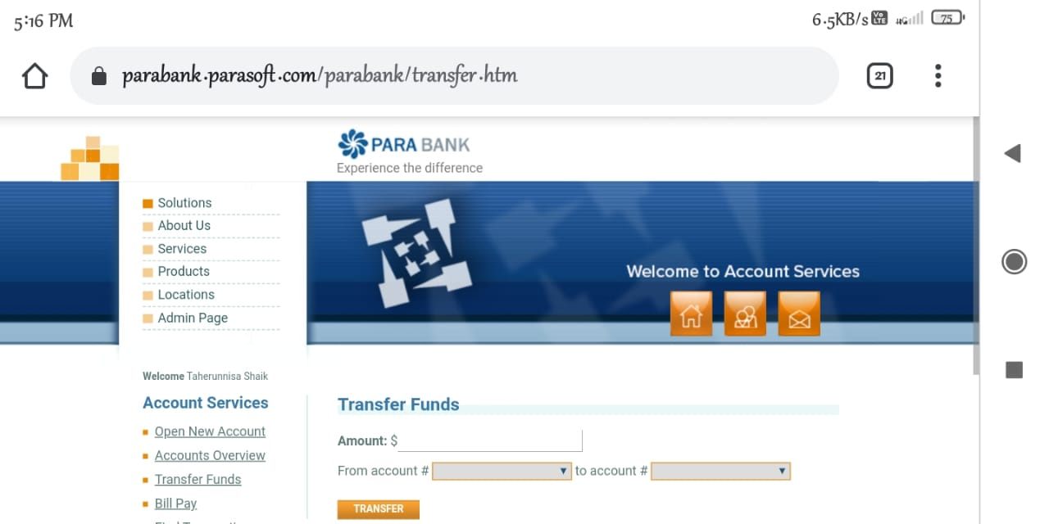

**TC42: To check the functionality of Transfer button**

w.findElement(By.*id*("amount")).sendKeys("30");

Select V=**new** Select(w.findElement(By.*xpath*("//*[@id=\"fromAccountId\"]")));//from account

V.selectByIndex(0) Select P=**new** Select(w.findElement(By.*xpath*("//*[@id=\"toAccountId\"]"))); //to account

P.selectByIndex(0);

w.findElement(By.*xpath*("//*[@id=\"rightPanel\"]/div/div/form/div[2]/input")).click(); //transfer button

System.***out***.println("Transfer funds successfully");

Thread.*sleep*(1000);

**TC43: To click on bill pay**

w.findElement(By.*linkText*("Bill Pay")).click(); // bill pay

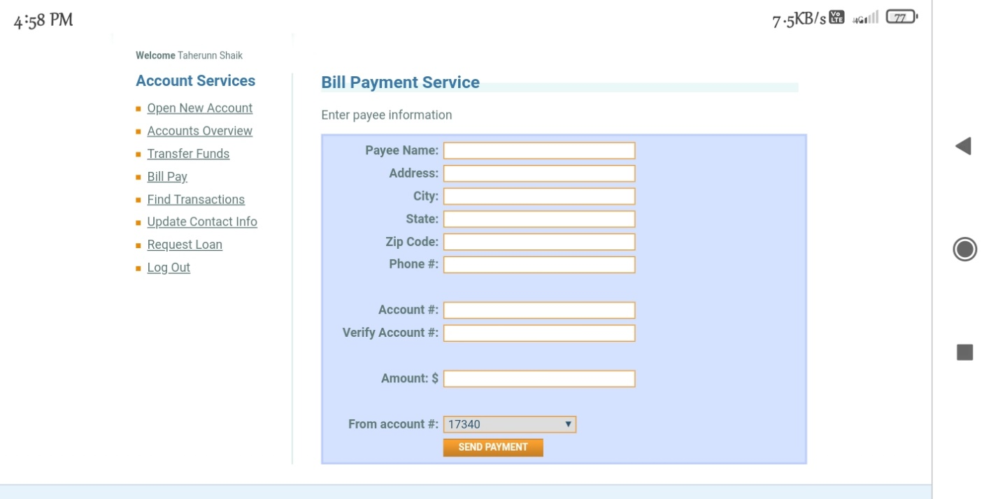

**TC44: To check the functionality of send payment**

w.findElement(By.*name*("payee.name")).sendKeys("Sk Appu");

w.findElement(By.*name*("payee.address.street")).sendKeys("Tenali");

w.findElement(By.*name*("payee.address.city")).sendKeys("Guntur");

w.findElement(By.*name*("payee.address.state")).sendKeys("AP");

w.findElement(By.*name*("payee.address.zipCode")).sendKeys("123456");

w.findElement(By.*name*("payee.phoneNumber")).sendKeys("6301785201");

w.findElement(By.*name*("payee.accountNumber")).sendKeys("1234");

w.findElement(By.*name*("verifyAccount")).sendKeys("1234");

w.findElement(By.*name*("amount")).sendKeys("10");

Select T =**new** Select(w.findElement(By.*xpath*("//*[@id=\"rightPanel\"]/div/div[1]/form/table/tbody/tr[13]/td[2]/select")));

T.selectByIndex(0);

w.findElement(By.*xpath*("//*[@id=\"rightPanel\"]/div/div[1]/form/table/tbody/tr[14]/td[2]/input")).click(); // send payment

System.***out***.println("send payement successfully");

Thread.*sleep*(2000);

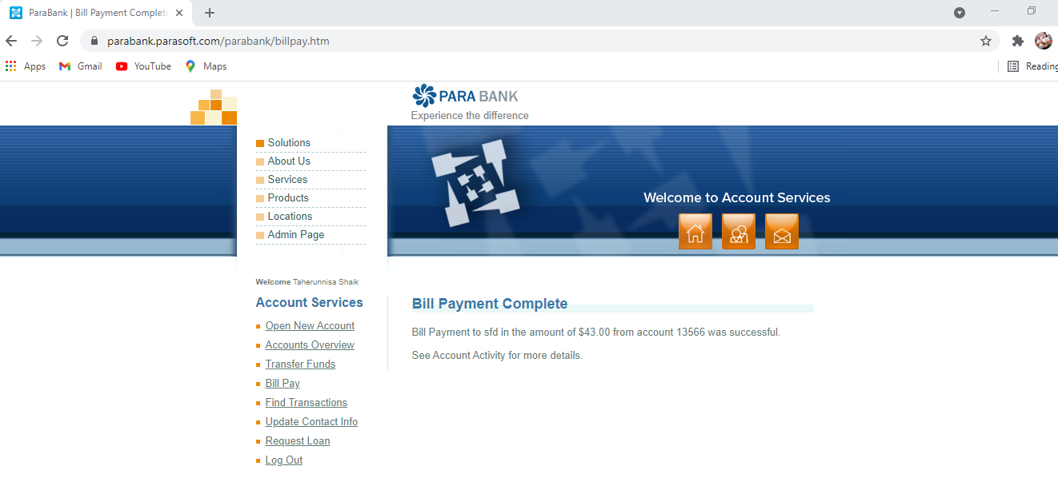

**TC45: To click on Find Transactions**

w.findElement(By.*linkText*("Find Transactions")).click();

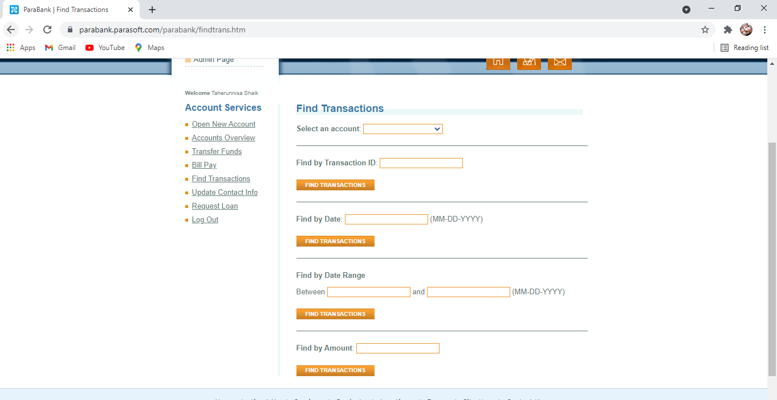

**TC46: To check the functionality of Find Transactions**

Select E=**new** Select(w.findElement(By.*xpath*("//*[@id=\"accountId\"]")));//select an account//

E.selectByIndex(0);

w.findElement(By.*xpath*("//*[@id=\"criteria.transactionId\"]")).sendKeys("1234");//find account//

w.findElement(By.*xpath*("//*[@id=\"rightPanel\"]/div/div/form/div[3]/button")).click();//click on find by trans id

**TC47: To check the functionality of Find Transactions**

w.findElement(By.*id*("criteria.onDate")).sendKeys("04-20-2021");

w.findElement(By.*xpath*("//*[@id=\"rightPanel\"]/div/div/form/div[5]/button")).click();

**TC48: To check the functionality of Find Transactions**

w.findElement(By.*id*("criteria.fromDate")).sendKeys("04-2-2021");

w.findElement(By.*id*("criteria.toDate")).sendKeys("04-20-2021");

w.findElement(By.*xpath*("//*[@id=\"rightPanel\"]/div/div/form/div[7]/button")).click();

**TC49: To check the functionality of Find Transactions**

w.findElement(By.*id*("criteria.amount")).sendKeys("515");

w.findElement(By.*xpath*("//*[@id=\"rightPanel\"]/div/div/form/div[9]/button")).click();

Thread.*sleep*(1000);

**TC50: To click on Update contact info**

//To click on update info

w.findElement(By.*linkText*("Update Contact Info")).click();

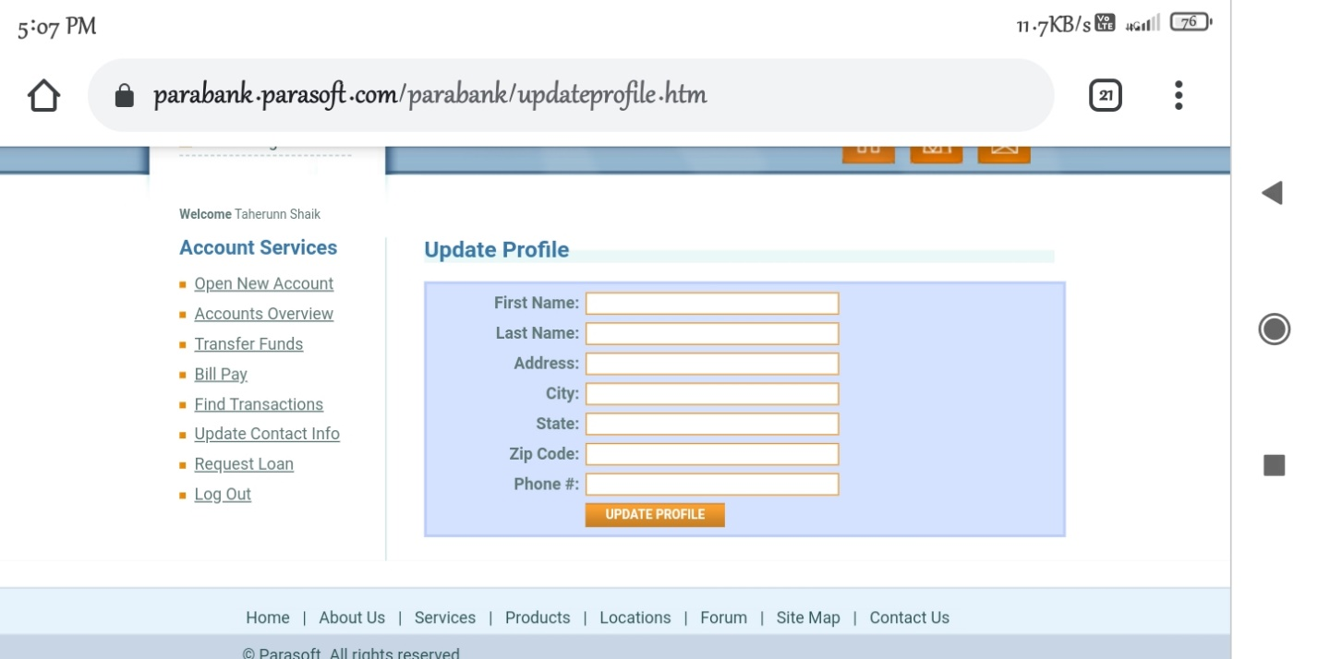

**TC51 : To check the functionality of UPDATE PROFILE**

//update info//

w.findElement(By.*name*("customer.firstName")).sendKeys("ppu");

w.findElement(By.*name*("customer.lastName")).sendKeys("Sk");

w.findElement(By.*name*("customer.address.street")).sendKeys("Bhatt");

w.findElement(By.*name*("customer.address.city")).sendKeys("Guntur");

w.findElement(By.*name*("customer.address.state")).sendKeys("TN");

w.findElement(By.*name*("customer.address.zipCode")).sendKeys("123567");

w.findElement(By.*name*("customer.phoneNumber")).sendKeys("6301784356");

//To submit update button//

w.findElement(By.*xpath*("//*[@id=\"rightPanel\"]/div/div/form/table/tbody/tr[8]/td[2]/input")).click();

Thread.*sleep*(2000);

System.***out***.println("Update profile Successfully");

**TC52: To click on Request Loan button**

//click on Request Loan//

w.findElement(By.*linkText*("Request Loan")).click();

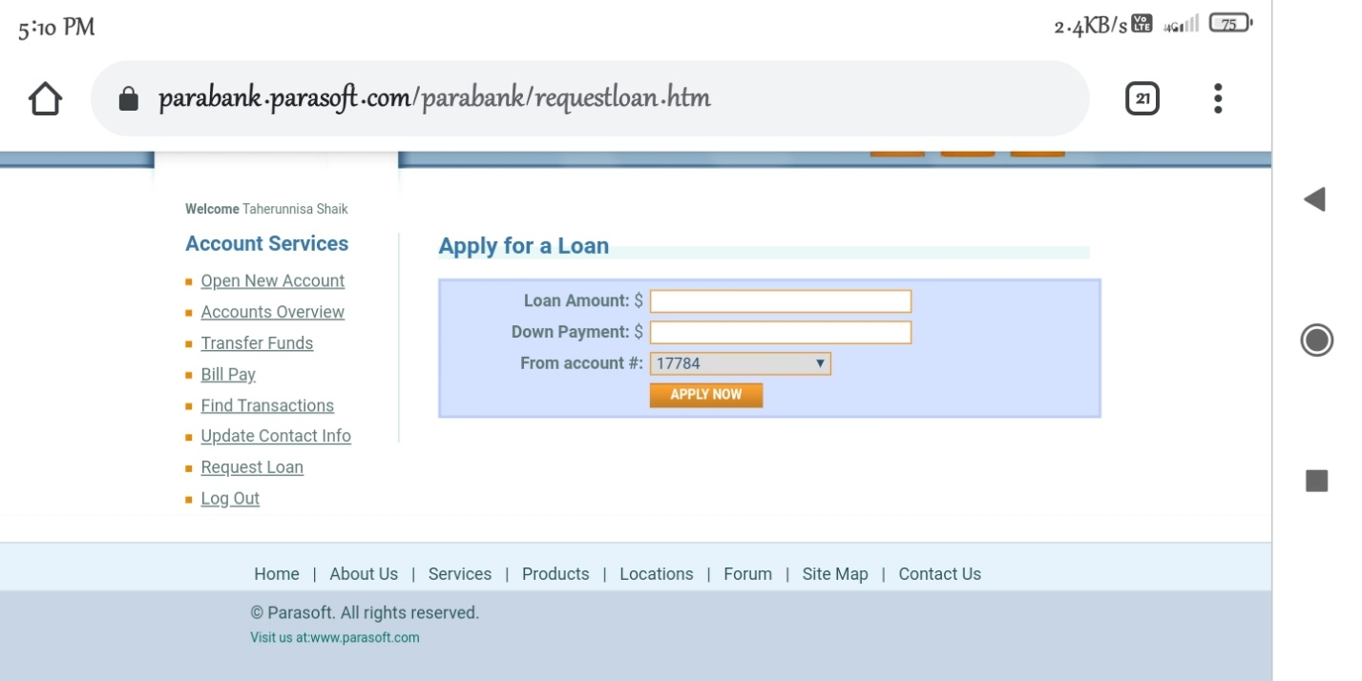

**TC53: To check the functionality of Apply now**

w.findElement(By.*id*("amount")).sendKeys("10000");

w.findElement(By.*id*("downPayment")).sendKeys("2");

//for dropdown to select from account// Select l= **new** Select(w.findElement(By.*xpath*("//*[@id=\"fromAccountId\"]")));

l.selectByIndex(0);

//to click on Apply button//

w.findElement(By.*xpath*("//*[@id=\"rightPanel\"]/div/div/form/table/tbody/tr[4]/td[2]/input")).click();

Thread.*sleep*(1000);

System.***out***.println("Request loan apllied successfully");

**TC54: To click on Logout button**

//To Logout//

w.findElement(By.*xpath*("//*[@id=\"leftPanel\"]/ul/li[8]/a")).click();

System.***out***.println("Logot successfully");

Thread.*sleep*(1000);

**TC55: To click on Forget Login info**

w.findElement(By.*linkText*("Forgot login info?")).click();

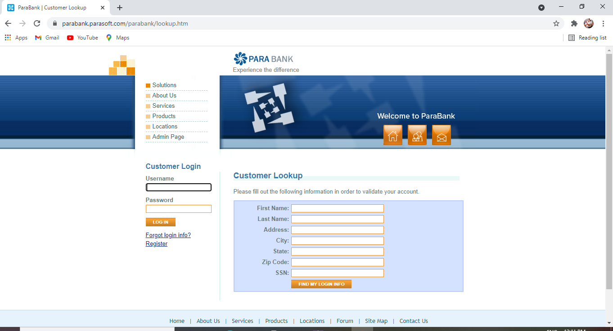

**TC56: To check the functionality of Find my Login info**

w.findElement(By.*name*("firstName")).sendKeys("Sk");

w.findElement(By.*name*("lastName")).sendKeys("Appu");

w.findElement(By.*name*("address.street")).sendKeys("Tenali");

w.findElement(By.*name*("address.city")).sendKeys("Guntur");

w.findElement(By.*name*("address.state")).sendKeys("AP");

w.findElement(By.*name*("address.zipCode")).sendKeys("123456");

w.findElement(By.*name*("ssn")).sendKeys("803413241567");

w.findElement(By.*xpath*("//*[@id=\"lookupForm\"]/table/tbody/tr[8]/td[2]/input")).click();

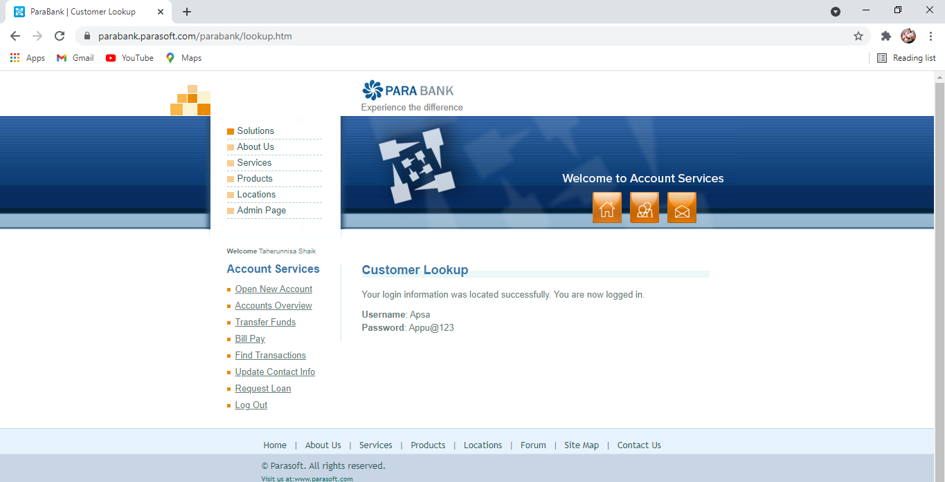

**TC57: To check the functionality of Logout button**

//To Logout//

w.findElement(By.xpath("//*[@id=\"leftPanel\"]/ul/li[8]/a")).click();

System.out.println("Logot successfully");

Thread.sleep(1000);

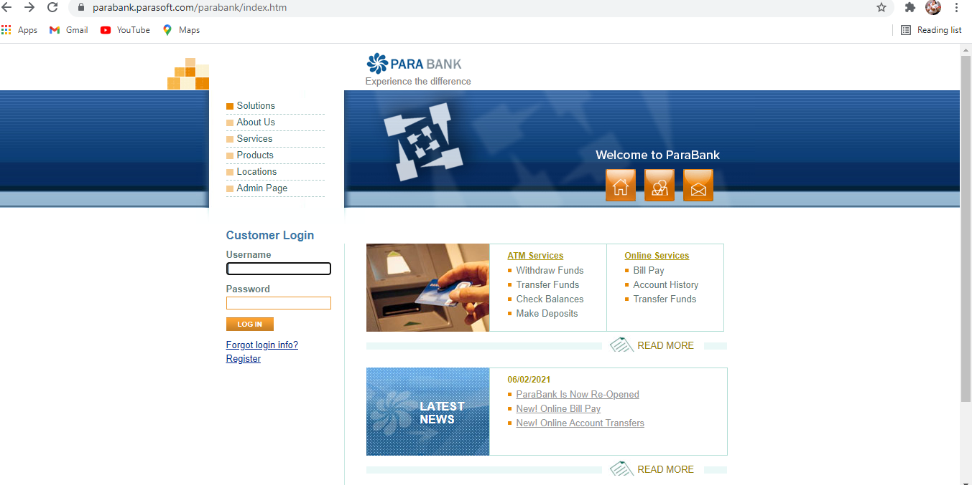

**TC58: To check the functionality of Login button**

//Login//

w.findElement(By.*name*("username")).sendKeys("SSAD");

w.findElement(By.*name*("password")).sendKeys("Appu@123");

w.findElement(By.*xpath*("//*[@id=\"loginPanel\"]/form/div[3]/input")).click();

System.***out***.println("Login successfully");

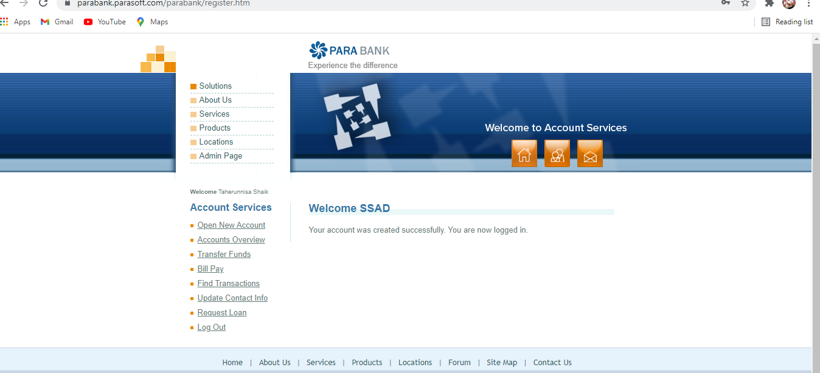

**TC59: To check the functionality of Forum**

//Forum//

w.findElement(By.linkText("Forum")).click();

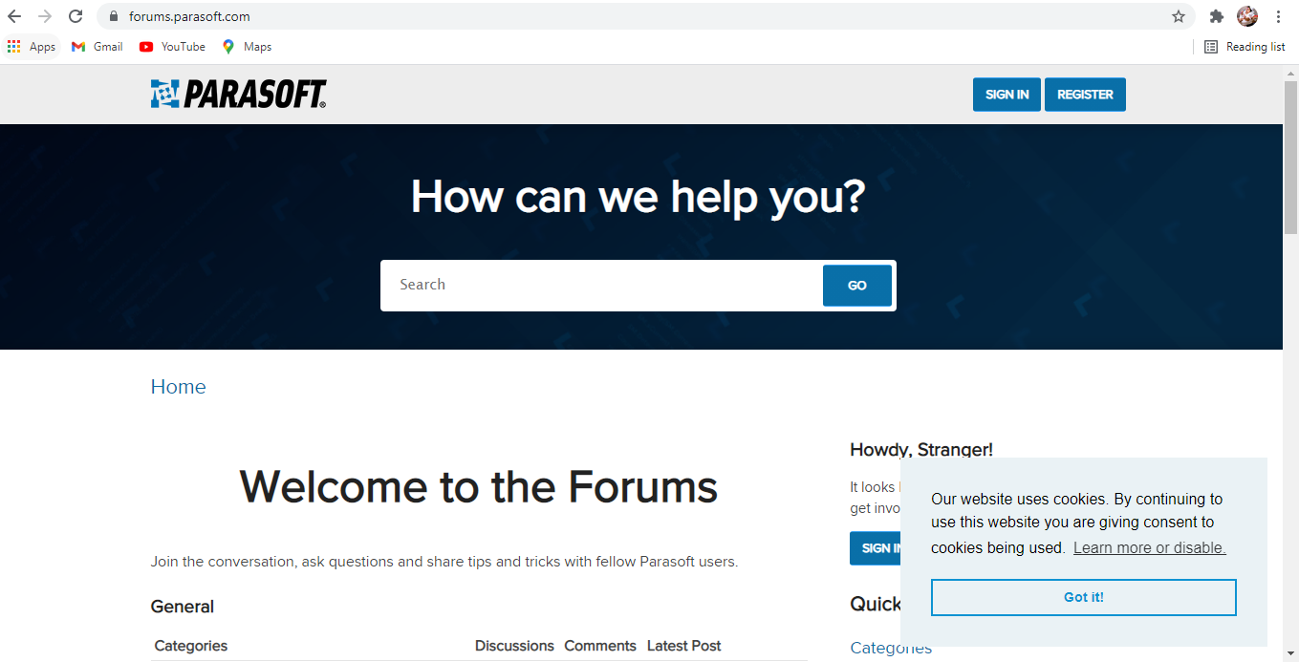

**TC60: To check the functionality of Go button for products**

w.findElement(By.name("Search")).sendKeys("products");//for products//

w.findElement(By.xpath("//*[@id=\"Form_Go\"]")).click();

JavascriptExecutor d = ( JavascriptExecutor) w;

d.executeScript("window.scrollBy(0,1000)",""); //ScrollDown//

Thread.sleep(1000);

w.navigate().back();

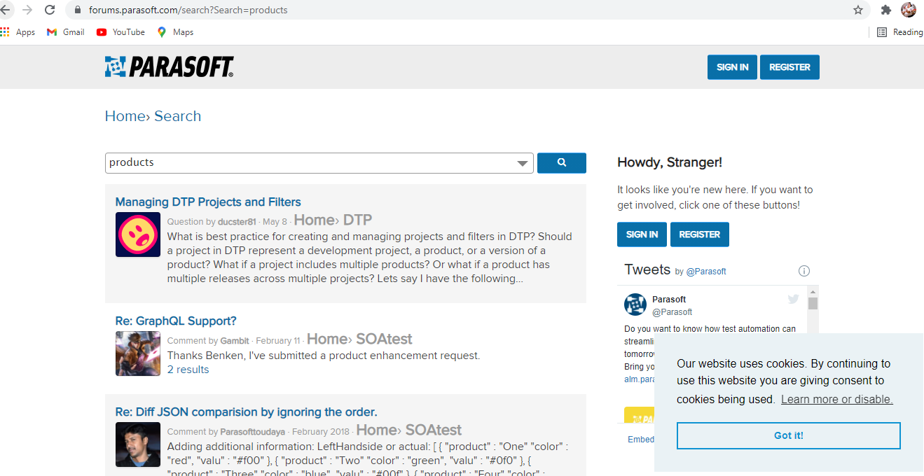

**TC61: To check the functionality of go button for services**

w.findElement(By.name("Search")).sendKeys("services");//Services//

w.findElement(By.xpath("//*[@id=\"Form_Go\"]")).click();

JavascriptExecutor de = ( JavascriptExecutor) w;

de.executeScript("window.scrollBy(0,1000)",""); //ScrollDown//

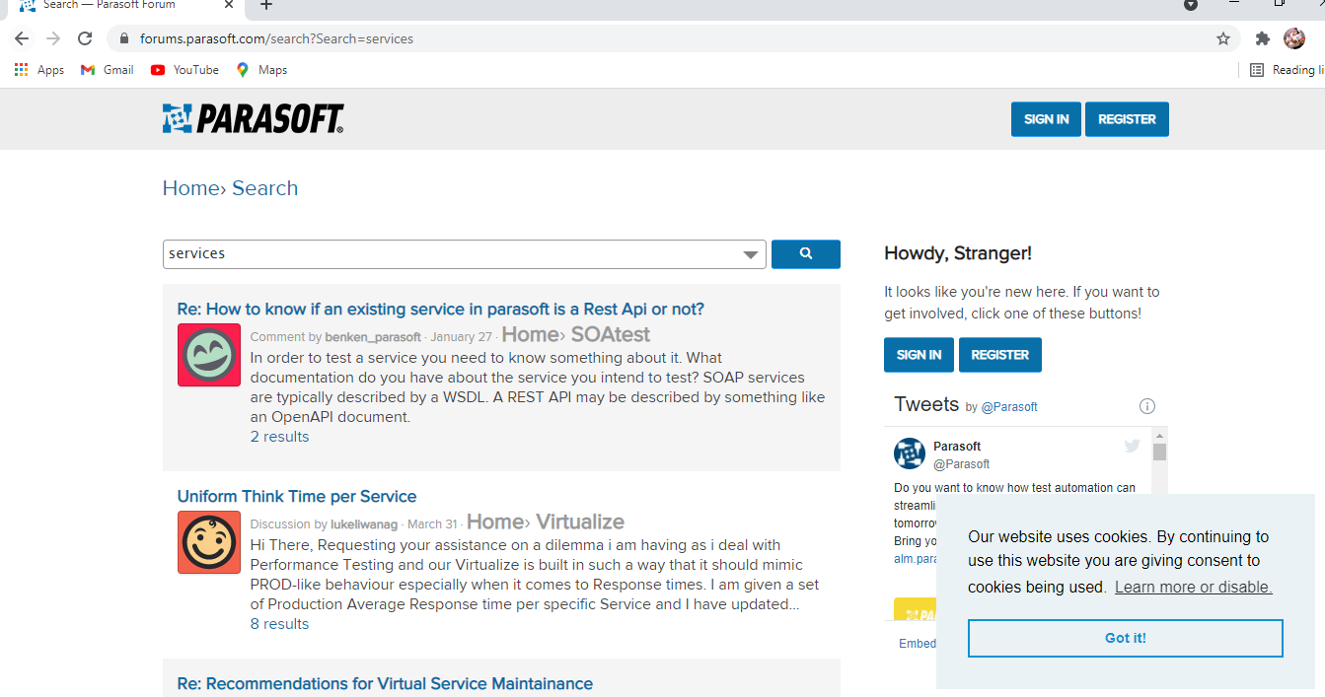

Thread.sleep(1000);

w.navigate().back();

JavascriptExecutor ded = ( JavascriptExecutor) w;

ded.executeScript("window.scrollBy(0,1000)",""); //ScrollDown//

Thread.sleep(1000);

w.navigate().back();

**TC62: To check the functionality of sitemap**

//sitemap//

w.findElement(By.linkText("Site Map")).click();

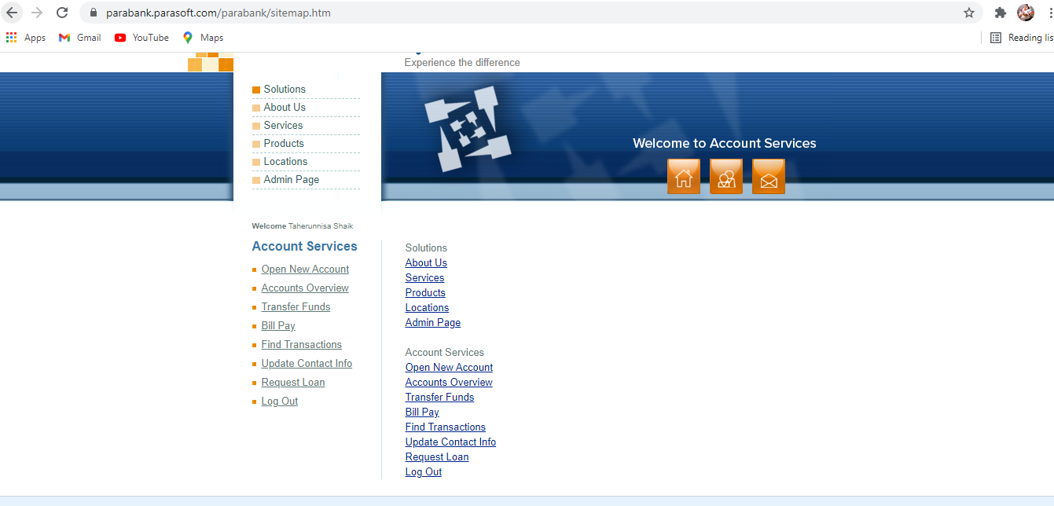

**TC63: To click on Contact Us**

//contact us/

w.findElement(By.linkText("Contact Us")).click();

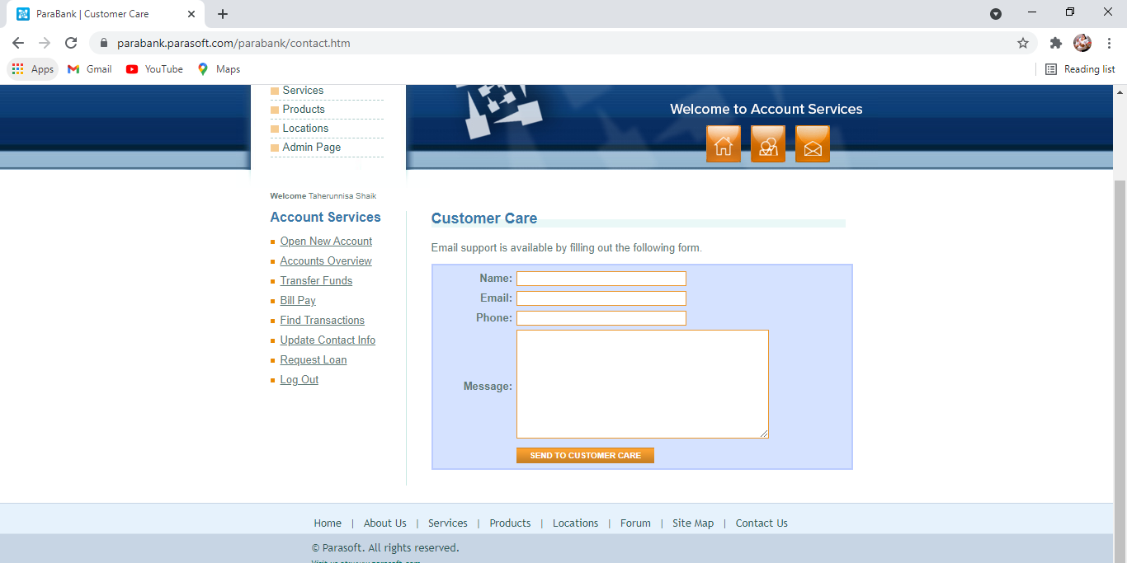

**TC64: To check the functionality of Send to customer care**

w.findElement(By.id("name")).sendKeys("abcd"); w.findElement(By.id("email")).sendKeys("abcd@gmail.com");

w.findElement(By.id("phone")).sendKeys("1234567890");

w.findElement(By.id("message")).sendKeys("good");

w.findElement(By.xpath("//*[@id=\"contactForm\"]/table/tbody/tr[5]/td[2]/input")).click();

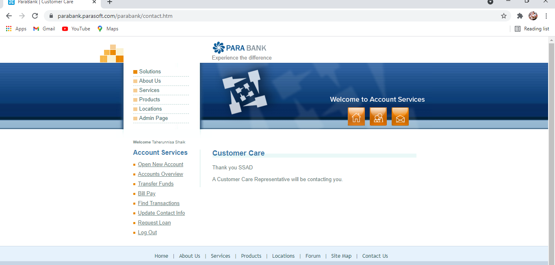

Thread.sleep(2000);

System.out.println("Thank You For Your Response");

w.close();

}

}